BAPTISM REGISTRATION FORM
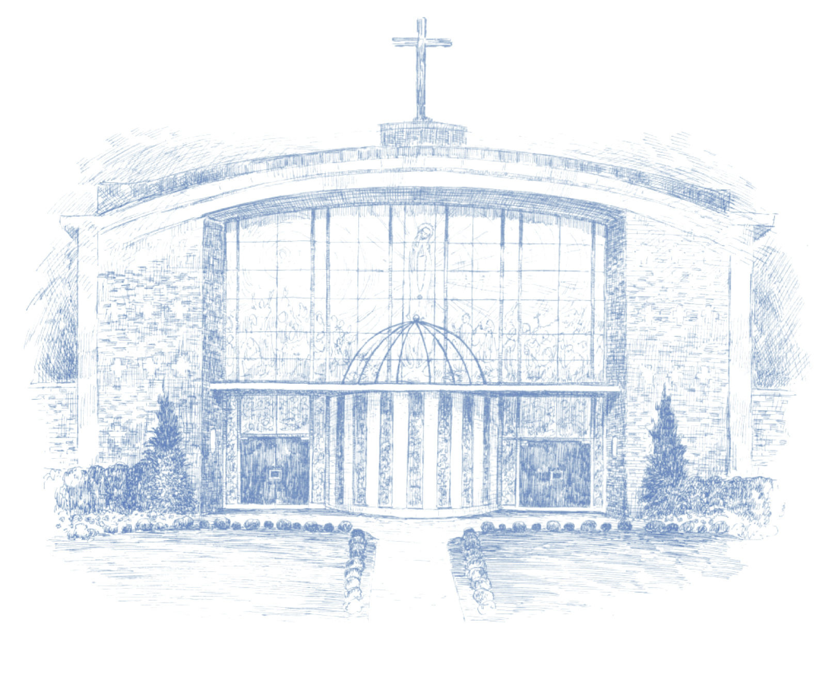
Our Lady of Fatima Catholic Church
2319 Johnston St.
Lafayette, LA 70503
(337) 232-8945 Phone
(337) 232-0323 Fax

Dear Parents,
Enclosed are the forms and guidelines for obtaining the Sacrament of Baptism at Our Lady of Fatima Catholic Church. We ask you to read it carefully and provide us with all information necessary as you prepare for the baptism of your child. All information needed is in conformity with the Guidelines for Baptism for the Diocese of Lafayette.
Baptism is no mere social convention, but the Sacrament in which Christ Himself purifies, justifies and sanctifies (cf. 1 Peter 1:23) your child for eternal life. We rejoice with you in the birth of your child and look forward to welcoming him into the family of God and the communion of the Holy Catholic Church.
If you have any questions, please call 337-232-8945. May God bless you and your child.
Mona Bouillion
Parish Secretary
1

CHECKLIST FOR BAPTISM
For Parents:
_____ Attend a Baptism Preparation Class, either at Our Lady of Fatima or another parish (if you have
taken a baptism class within the past two years, you do not need to take another class).
_____Complete page 3 & 4 of the Baptism Request Form and turn in to the parish office at least one
month before the baptism, along with the following:
_____Copy of your child’s State-registered Birth Certificate

_____Certificates of attendance at a Baptism Preparation Class within the past two years, for parents
and Godparents
_____If you are not a parishioner of Our Lady of Fatima - A letter from your parish pastor granting
permission for your child to be baptized at Our Lady of Fatima
_____Completed and signed Godparent Information page
For Godparents:
_____ Inform Godparents of their requirements to attend a Baptism Preparation Class (again, if they
have taken one of these classes within the past two years, this will not be necessary).
_____ Please read and complete the Godparent section and have Godparent(s) sign.
Requirements for Godparents for your child as stated in Canon Law 874:
• Be designated by parents, guardians, or pastor
• Have the intention of performing the role of sponsor
• Be at least 16 years old
• Be a fully initiated Catholic (received Baptism, First Communion and Confirmation)
• Lead a life in harmony with the Faith and role of a sponsor (i.e. be a registered member of a parish, attend Mass on Sundays and Holy Days and faithful to the laws of the Church regarding marriage)
• Not bound by any canonical penalty
• Not the father or mother of the candidate
At least one of the persons you choose must fulfill these requirements. A baptized non-Catholic may not be a Godparent, but may serve as a Christian Witness along with a Catholic Godparent. Non-baptized persons may not serve as a witness or Godparent. Remember, Baptism is not a one-time event; you are committing your child to a way of life in the Catholic faith. That means you must be working to follow that faith as well.
All forms must be complete before turning in and all documents must be received before we will proceed with the baptism.
2
Baptism request form
Please print names correctly and all information clearly.
Name of Child: First ____________________ Middle _________________ Last _______________________

Date of Birth ________________City & State of Birth_______________________ Sex of Child____________

Name of Mother:First___________________Middle____________________Maiden_____________________

Religion of Mother__________________________________ Daytime Phone___________________________

Baptized? ____________ Confirmed? ____________ Taken class?_____________ Date__________________

Name of Father:First_____________________Middle____________________Last______________________

Religion of Father___________________________________ Daytime Phone___________________________

Baptized? ____________ Confirmed? ____________ Taken class?_____________ Date__________________

Mailing Address____________________________________________________________________________

Parish where you are registered________________________________________________________________

Do you attend Mass every Sunday? Mother_________________________ Father________________________

If not, how often do you attend Mass (weekly, monthly, never or other)? Mother___________ Father_________

Are you married? _______ Name of Church ______________________________________________________

Date of Marriage ______________________ City & State ___________________________________________

If not married in a church, where were you married? _______________________________________________

Requested Date of Baptism (choose two dates):____________________________________________________

We hereby request the Sacrament of Baptism for our child:
Father ___________________________________________________________ Date ___________________ Mother __________________________________________________________ Date ___________________

Office use only: Date of Baptism___________________________________________
Name of Priest/Deacon_____________________________________________________
3
Choice of Godparent
Godparents must have an active faith practice – Mass every Sunday (not just sometimes). They are to be confirmed Catholics, able to receive Holy Communion (that is living in a state of grace). If the Godparent is married, he/she must be in a valid sacramental marriage blessed by a priest/deacon. Only one Godparent is required by the Church, but most couples choose a second Godparent. The Church does not allow two Godparents of the same sex or more than two Godparents. This is the universal norm that must always be followed.
Note: At times, a couple will often say that they don’t have family members who practice their faith. If this is the case, then try looking for good friends. Certainly we all know someone who has an exemplary faith practice. If it is discovered that your choice of Godparents does not meet ALL of the requirements outlined above (Sunday Mass every week, etc.), then the baptismal date of the child will be postponed until the requirements are met.

Print Godfather’s Name _____________________________________Religion___________________ (First, Middle, Last)
Baptized? ____________ Confirmed? ____________ Taken class?___________ Date_____________

Will the godfather be present at the ceremony? _____Yes _____No

If not present for the ceremony, who will be the proxy? Name ________________________________
(First, Middle, Last)

Print Godmother’s Name ____________________________________ Religion__________________ (First, Middle, Last)
Baptized? ____________ Confirmed? ____________ Taken class?___________ Date_____________

Will the godmother be present at the ceremony? _______Yes _______No

If not present for the ceremony, who will be the proxy? Name ________________________________
(First, Middle, Last)

PROMISE OF GODPARENTS: We (I) promise to God and to His Holy Catholic Church, that we (I) meet all the requirements regarding the role and duty of the godparent, so help us (me) God.

___________________________________ __________________________________
Signature of Godfather Signature of Godmother

If your Godparent(s) live(s) out of town, do your best to get their signatures on this form or have the Godparent download and sign another form and mail it to us.

4

